How to create SS( successful student )application

**1)Main Class**

package sample;

import javafx.application.Application;

import javafx.fxml.FXMLLoader;

import javafx.scene.Parent;

import javafx.scene.Scene;

import javafx.stage.Stage;

import java.util.ArrayList;

import java.sql.Statement;

import java.sql.ResultSet;

import java.sql.SQLException;

public class Main extends Application {

public static ArrayList<String> arr=new ArrayList<String >();

@Override

This method is creating a window

public void start(Stage primaryStage) throws Exception{

Parent root = FXMLLoader.load(getClass().getResource("sample.fxml"));

primaryStage.setTitle("Ala-too");

primaryStage.setScene(new Scene(root, 800, 600));

primaryStage.setResizable(false);

primaryStage.show();

}

This method is taking student’s names from database and running the window

public static void main(String[] args) throws SQLException {

DBworker worker = new DBworker();

String query ="select * FROM [Students].[dbo].[Studnets]";

try{

Statement statement = worker.getConnection().createStatement();

ResultSet resultSet =statement.executeQuery(query);

while (resultSet.next()){

Users users = new Users();

users.setName(resultSet.getString(1));

arr.add(resultSet.getString(1).replaceAll("\\s+",""));

}

}

catch (SQLException e){

e.printStackTrace();

}

launch(args);

}}

2)DBWorker Class

package sample;

import java.sql.*;

public class DBworker {

private static String URL ="jdbc:sqlserver://localhost:1433;instanceName=Адока;databaseName=Students";

private static String USERNAME = "root";

private static String PASSWORD = "root";

private Connection connection;

This method is connecting our project with db

public DBworker(){

try {

connection = DriverManager.getConnection(URL, USERNAME, PASSWORD);

}

catch (SQLException e){

e.printStackTrace();

}

}

public Connection getConnection(){

return connection;

}

}

3)Controller

package sample;

import java.io.IOException;

import java.net.URL;

import java.util.ResourceBundle;

import javafx.fxml.FXML;

import javafx.fxml.FXMLLoader;

import javafx.scene.Parent;

import javafx.scene.Scene;

import javafx.scene.control.Button;

import javafx.scene.control.Label;

import javafx.scene.control.TextField;

import javafx.stage.Stage;

import static sample.Main.arr;

public class Controller {

@FXML

private ResourceBundle resources;

@FXML

private URL location;

@FXML

private TextField text_field;

@FXML

private Button login;

@FXML

private Label wrong_input;

@FXML

void initialize() {

login.setOnAction(event -> {

This statement is passing only teachers and moving to teacher’s part

if(text_field.getText().equals("ruslan.isaev")){

login.getScene().getWindow().hide();

FXMLLoader loader = new FXMLLoader();

loader.setLocation(getClass().getResource("/sample/sample4.fxml"));

try {

loader.load();

} catch (IOException e) {

e.printStackTrace();

}

Parent root =loader.getRoot();

Stage stage = new Stage();

stage.setScene(new Scene(root));

String title = "Ala-too";

stage.setTitle(title);

stage.setResizable(false);

stage.show();

}

else {

This statement is passing only students and moving to students’s part

if (arr.contains(text_field.getText())) {

login.getScene().getWindow().hide();

FXMLLoader loader = new FXMLLoader();

loader.setLocation(getClass().getResource("/sample/sample2.fxml"));

try {

loader.load();

} catch (IOException e) {

e.printStackTrace();

}

Parent root = loader.getRoot();

Stage stage = new Stage();

stage.setScene(new Scene(root));

String title = "Ala-too";

stage.setTitle(title);

stage.setResizable(false);

stage.show();

}

This statement showing that input is incorrect

else wrong_input.setText("Wrong input!!!");

}

});

}

}

4)Students part

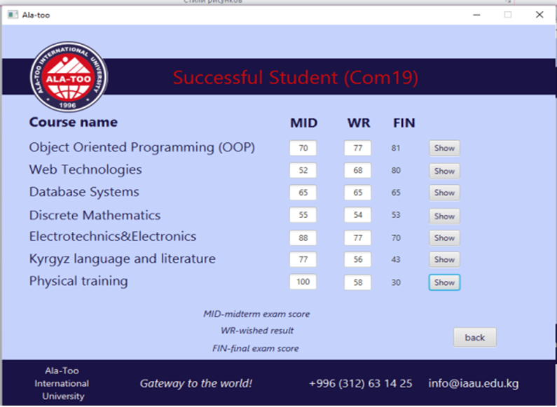You should write all your lessons and create 2 textfields(midterm and wished result) for each of them and make a button(“show”) with empty label near it.

Code :

button.setOnAction(actionEvent -> { int final=(wished_result -(midterm *40/100))*100/60;

label.setTest(String.valueoff(final))

}

5)Teachers part

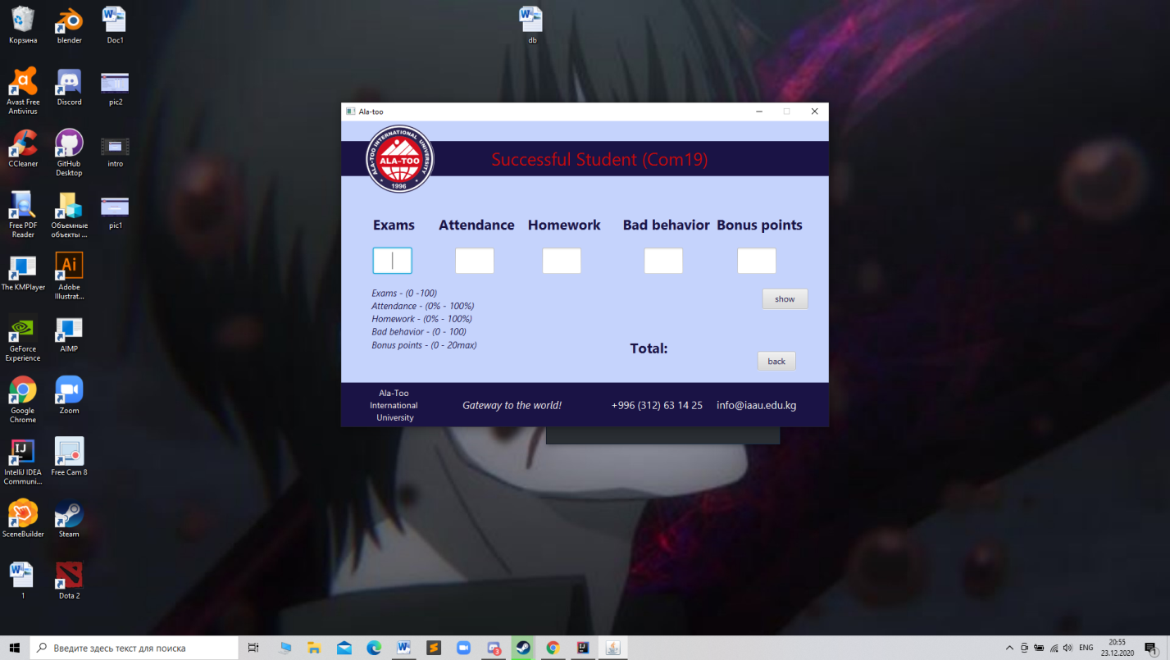You should write :exams,attendance,homework,bad behavior,bonus points and create textfield for each of them and make a button(“show”) with empty label near it.

Code :

button.setOnAction(actionEvent -> { int total=((exams*80/100)+attendance/10+homework/10)- bad_behavior+bonus_points;

label.setTest(String.valueoff(total))

}